CS691 - Computer Science, Spring 2021

Project Initiation Document

Project: Food Pantry

Project Manager: Yash Kawade

Start Date: 1/24/22

Completion Date: 12/22/22

Table of Contents

Document Purpose (Aleks) **4**

Background to the Proposed Work (Pratikkumar & Aleks) **5**

Vision (Christus) **5**

Project Objectives (Yash) **5**

Project Scope (Christus) **6**

Business Case (Aleks) **6**

Assumptions (Yashraj) **12**

Constraints (Yashraj) **1**3

Risk Management Strategy (Yash & Aleks) **1**4

Deliverables (Aleks) **1**7

Stakeholders (Yash) **17**

Project Team (Aleks & Pratikkumar) **1**8

Project Plan (Yashraj) **19**

Project Controls (Venkata) **19**

Communication Plan (Pratikkumar & Venkata) **20**

Document Details

| Version | Modifications | Author | Date |
| --- | --- | --- | --- |
| 1 | Initial draft | Team 5 | 02/11/2022 |
| 2 | Address changes needed for page 3, Team Plan and Project Plan | Lead Developer, PM | 02/22/2022 |
|  |  |  |  |
|  |  |  |  |

Approvals

This document requires the following approvals:

| Name | Role | Signature | Date | Version |
| --- | --- | --- | --- | --- |
| Yash Kawade | Product Manager | YK | 02/11/2022 | 1 |
| Aleks Kamenev | Product Owner | AK | 02/11/2022 | 1 |
| Prof. Yuri | Approver |  | 02/12/2022 | 1 |
|  |  |  |  |  |
|  |  |  |  |  |
|  |  |  |  |  |

Distribution

This document has been distributed to:

| Name | Role | Date of Issue | Version |
| --- | --- | --- | --- |
| Whole of Team 5 |  | 02/13/2022 | 1 |
|  |  |  |  |
|  |  |  |  |
|  |  |  |  |

# Document Purpose (Aleks)

Food Pantry aims to be an organizational and communicational resource to help facilitate the donation of food and food goods to people in need. We aim to be a force for positive social change. As the gap between economic classes grows larger and larger, it is more important than ever to uphold the values of goodness and kindness. To this end, we have set out on a mission to create a platform where both time and food can be donated, so those of us who require sustenance can find it. We wish to build a platform where givers can offer food and food goods, couriers can volunteer their time to transport said goods, and most importantly receivers can be helped in their time of need.

To achieve this task, a diverse team of legal experts, advertisement experts, and software developers will be brought together. As there are potential tax offsets when donations are involved, legal council is important and needed. In order to both popularize the platform and manage advertisement on the platform itself, an advertisement team will be employed. Last but not least a team of software engineers and developers will be essential for the creation and maintenance of the project.

The purpose of this document is to provide a wholesome and complete understanding of the project, its organization, the work, and manpower involved in its completion and to act as a de facto roadmap.

This document will cover the project objective and scope, as well as all of the required personnel and materials needed to meet our desired outcome.

The PID describes the necessary properties for Food Pantry:

· Initial approach and ideation

· Member roles and responsibilities

· Necessity and execution

· Day to day processes

· Workflow and communication between departments and stakeholders

· Risk management

· Project planning, milestones, and deliverables

While there is a possibility of this document to undergo changes throughout the course of the project's execution, it is most important to refer to this text when big decisions need to be made or to determine the best course forward in times of uncertainty.

# Background to the Proposed Work (Pratikkumar & Aleks)

# FoodPantry is a comprehensive platform aiming to facilitate the donation of food and food goods to those in need. We strongly believe there are good people out there willing to help by either donating goods or by volunteering their time in order to help their fellow humans. To this end, we plan to build a cross-platform application that will limit the organizational overhead and make it as easy as possible for businesses and individuals to do good.

Upon completion, we expect the platform to act as an organizational portal and a listing roster for food to be redistributed from those who wish to give it to those who need it. We expect the platform to be a strong force for positive social change.

Not completing this project would be a huge missed opportunity to impact society in a positive way. This project will also alleviate pressures for food banks and shelters to find resources and offer businesses tax breaks for their contributions making it a profitable business decision as well as social.

# Vision (Christus)

It is our interest to reduce food wastage and provide food to the needy. Hence, we provide a first-class platform that aggregates food providers and food donors to a one-stop-shop for collaboration and exchange for food resources. Food providers put up a catalog of foods for distribution, informing prospective donors to acquire said resources.

# Project Objectives (Yash)

* To create an application that will allow restaurants and food retailers to connect with NGOs (non-governmental organizations) and volunteers to help the needy
* Application will allow restaurants and food retailers to notify that they have food to give
* Volunteers, NGOs and food retailers register with a login id and password
* Volunteers/NGOs can use the application features to track which restaurants are providing food
* Volunteers/NGOs can reserve/claim the food to pick up and later give it to the needy
* Individual users can also login to the application and donate food
* Advertisement sections would be allotted in the application to generate revenue
* Payment gateway to be provided for conducting fund collections and subscriptions with robust security
* In-app navigation will also be provided to the volunteers/NGOs for restaurants
* Certifications and tax deductions for goodwill to be enlisted and tracked down.

# Project Scope (Christus)

Our scope is to connect food providers to food donors

* What the project must deliver
  + An interactive and accessible UX/UI experience
  + A robust and reliable database
  + Information of Food providers to donors
* What’s in and out of scope
  + IN SCOPE
    - Register and provide a list of food providers
    - Allow food providers display available stock of food resources
    - Register food donors (NGOs and volunteers)
    - Generate a catalog for food donors to view and accept donations.
    - Keep records of interaction between two parties
  + OUT OF SCOPE
    - Providing logistics for the distribution of the food.
* The impact of the project – geographically, financially, etc.
  + Environmentally- Reduce food wasting by food providers.
  + Geographically- Help donors acquire food for the needy in New York.
  + Financially- Help food providers and food Donor obtain tax deductions.
  + Social - Allow for the redistribution of food from those who have it in excess to those that need it the most

# Business Case (Aleks)

Business Case

| Application Name | Food Pantry |
| --- | --- |
| Type of business model | Crowdsourcing: We will offer access to the application for free and collect data over time.   Advertising: Ads will be used in the app as an additional source of income to keep the project supported.  Donation: As this is a social care centric project we will also rely on donations, grants, and fundraising.  Subscription: By allowing users to subscribe for a recurring payment we provide a continuous way to support the project. (As this is a charity based work, tax write-offs are a potential benefit for users) |
| Target audience of external users  (Customer Segments) | For whom are we creating value?  NGOs, volunteers, food retailers, and people in need.  Who are our most important customers?  Food retailers (as a source of goods), NGOs(to distribute goods to people in need), and end food receivers.  As this is a tightly dependent chain all three types of users are equally important and without one type the project would simply not work. |
| Groups of internal stakeholders, business users | *Indicate who will be using the system.*  Do we need a product development group?  Yes, to build and develop the application/platform.  Do we need a sales group?  No, as we are not actually selling a product.  Do we need a finance group (accounts payable, receivable)?  Yes, we do. For the purpose of finding investors and patrons. Other needs include fundraising.  Do we need a customer support team?  Yes, as we are working with a diverse set of end-users.  Do we need an advertising management group?  Yes, we will. For the purposes of finding NGOs and attracting restaurants to the platform. To help increase exposure. |
| Value propositions | What value do we deliver to the customer?  The main goal of the platform is to reduce food waste and to enhance food distribution so it makes it to those who need it the most.  Which one of our customer’s problems are we helping to solve?  Food wastage, shortage of food, and a need to give back to the community. By facilitating the allocation of food that would otherwise be discarded and bringing it to those in need of it we solve the three main issues we have set out to resolve. We also address the issue of food waste disposal. By donating food while it is still good for consumption businesses limit the costs they would incur if they had to dispose of it themselves.  What bundles of products and services are we offering to each  Food retailer: An easy way to give back to the community by donating their food supplies that would otherwise be disposed  of.  NGOs and volunteers: A place to organize and access food goods easily.  Customer Segment?  food providers, food distributors, food receivers.  Which customer needs are we satisfying?  Need to organize connections between NGOs, volunteers, and food retailers. We abstract the organization part of the process and allow end entities to focus on the real work of giving. |
| Key resources | What Key Resources do our Value Propositions require?  Team of developers to create and support the platform and a team of social and financial advisors for the needs of funding and exposure.  A recruitment team for securing a good-sized starting pool of food retailers may also be essential.  Our Distribution Channels?  Our website and the respective smartphone platforms (App Store and Play Store).  Customer Relationships?  The nature of customer relationships is of a self-service character. Users(food retailers) list available produce/meals and users(NGOs and volunteers) claim the item and are responsible for its redistribution.  Revenue Streams?  Ads, grants, and donations. |
| How the system is used | What are the main business use scenarios?  Overview:  Food Pantry aims to connect NGOs and volunteers with restaurants and food retailers for the purpose of redistributing food to those who need it. Food that would otherwise be disposed of. A (giver) would list items they wish to make available on the platform and the first (courier) to claim the offer is responsible for picking up the package and redistributing it to people in need. Once the package has been picked up there are two options for its delivery. One the (courier) who has claimed the package delivers it to an individual or individuals who are in need of their choice and not affiliated with the platform. Such individuals may be but are not limited to the homeless, low-income, or elderly people in need of food. Two, the (courier) chooses one of the registered (receivers) and delivers the food to that person or persons.  NGOs and volunteers are responsible for delivering packages to people in need. If the couriers choose to deliver it to a registered user in-app, navigation will be provided.  The platform aims to be a mediator or a middle person between the three separate entities. However, we as an organization are not responsible for the actual delivery.  Types of users:  Giver: This type of user is a food retailer, a restaurant, or an individual. The role played by this type of user is to make food and consumable goods available on the platform. This is done via a user interface that allows users to provide names, types, descriptions, and pick-up times for one or more items. *(There is room for expansion here)*  Couriers: The sole purpose of this type of user is to claim a package once it is made available on the platform. By claiming a package the courier takes responsibility for its delivery. Once a package has been claimed it is removed from the rooster. Both NGOs and volunteers fall under this type of user.   Receivers:  This is a type of user intended for people who are in need of help. The principle is simply an individual or individuals in need of food make an account stating their needs, location, and possible time windows for deliveries. Once set up they enter a rooster from which deliverers can select.   Keynotes:  Givers are able to select what types of couriers they wish to be able to work with. They may also make scheduled recurring periodical automatic listings and they may also set a preferred end receiver type.  Couriers will be able to set a scope on the size of the package they are able to handle or the time in the day they are available.   Receivers will be able to set a priority on the types of items they require.  All users will be able to set a zone of operation. That is, for givers and couriers an area in which they operate. For receivers, an area where they wish to receive goods.  One potential way to verify packages make it to the intended destinations is via photographic capture at the end of a delivery. |
| Revenue generation, Revenue streams | 1. Ads By entering into a legal agreement with FoodPantry the company, other entities will be able to purchase advertising space on the platform. We retain rights to determine what content is appropriate for the platform. 2. Subscription and Community funding Via fundraising and donations made to the company FoodPantry. Calls to action and donation requests will periodically be made on our website, in-app, and via email. Both the app and the website will have a donation section that allows users to support the project. Donations will be handled through card and Paypal payments. A subscription panel will also be available. In essence, this is a recurring donation. 3. Data collection Data collected through user interaction with our systems on the platform will be conscientiously monetized. Possible uses include market research projects.   To be explicitly clear these are the main ways for monetary transactions to be handled.  In-app or via the website: This type of payment occurs when a user either donates or subscribes. The payment will be credited to a bank account of the company.  Payments for an advertisement & donations: To be paid via check or direct wire transfer to a bank account belonging to FoodPantry. |
| Key Partners/Suppliers  (Stakeholders) | A strong initial base of food retailers and restaurants as well as a few key NGOs.  We will also require a business account with a bank of our choice (more research needed) and a business PayPal account. The purpose of these two accounts is to be able to receive incoming payments. |
| Expected Benefits | Minimize food wastage and provide much-needed food to people in need. Create a bridge between NGOs and restaurants. |
| Known Prototypes | Reference some known portals on the Internet that are similar to your business case. You will use these prototypes for developing business, user requirements.  [*TooGoodToGo*](https://toogoodtogo.com/en-us/business?utm_medium=search&utm_source=google&utm_campaign=us_b2b_paid_marketing_search_google_brand&utm_content=127049537214&utm_term=too%20good%20to%20go&ad_creative=552063345318&ad_extension&ad_position&visitor_device=c&hsa_net=adwords&hsa_ad=552063345318&hsa_acc=2882638550&hsa_src=g&hsa_cam=1741014919&hsa_ver=3&hsa_kw=too%20good%20to%20go&hsa_tgt=kwd-329997651495&hsa_grp=127049537214&hsa_mt=e&gclid=Cj0KCQiArt6PBhCoARIsAMF5wajh2QWWsBqeOg7pHY6dtHUbC-zcnsYPzox2nRApevq9Mx6uPvtF3mUaAnk9EALw_wcB) |
| Front-end Technology | Indicate what technology will be used to develop the front-end of your application.  Ionic, React, CSS |
| Back-end, Database Technology | Indicate what technology will be used to develop the back-end database of your application. The database should be relational.  SQL, Postgres, AWS |

# Assumptions (Yashraj)

| Assumption | Validated by | Status | Comments |
| --- | --- | --- | --- |
| Team member selection | Professor | completed | All team members have been decided. |
| Budget | All members | In process | The budget for each member will be around 100$. |
| Meeting | Product Manager | In process | Manager will schedule Two meetings  every week. |
| Team Work | All members | In process | Manager will keep details of all Modules and team members will decide ‘Single or Team’ work on specific modules. |
| Suppliers’ Support | Product Owner | In process | Owner needs to ensure support from restaurants and supermarkets for the food supply and quality. |
| Skill Requirement | All members | In process | All members should cooperate on programming. |
| Participation | All members | In process | Everyone should participate in weekly meetings. The assigned task should be completed in a timely manner. |
| Technology for  development | Business Analyst | In process | Business Analysts will keep the track of the latest technologies for the development. |
| All team members will stay | All Members | completed | All members have decided to take Project II next semester. |

# 

# Constraints (Yashraj)

* Scope: The scope of a project relates to its size in terms of quality, detail, and deliverables. Time and money are dependent on project scope because as the scope of the project expands, more time and money will be required to finish it.
* Deadlines and Time: As this is a team project, there are several members involved, each with their own schedule and time constraints. Each member must arrange their own time to complete individual work for this project within the given weekly deadline, and as a team, we must work around everyone's schedule to find a time to meet that is convenient for everyone.
* Cost: Cost constraints include the project budget as a whole and anything of financial value required for the project. Items that may be a cost constraint include
  + data storage facility (cloud server)
  + marketing
* Resources: these projects cost money, resources are strongly linked to cost limits on your project. Without adequate resource allocation, project quality may suffer, as well as budget and deadline setbacks.
* Requirements: Requirements: we have to make sure to collect enough data about Legal requirements of tax deduction certificate and limit of tax deductibles. Other factors to look into are generation of donation certificates, requirements for user friendly experience of the app and what are food quality assurance (handling, manufacturing, packaging) requirements.
* Quality: The quality of your project deliverables is determined by how well they satisfy your initial expectations. Because project quality is the end product of your project, every project limitation has an impact on it. Factors that may affect quality:
  + Lack of communication
  + Poor design or development skills
  + Too many project changes
* Limitations due to other projects or programs: As all members actively have other Classes going on throughout the year, the scope and extent of the project needs to be discussed. The project should also set realistic expectations from the developer team based on knowledge and availability of the technology to be used. One of the biggest limitations will be funding/cost.

# Risk Management Strategy (Yash & Aleks)

This section will include the risk mitigation and management techniques and strategies that will be applied to the project.

| Risk | Probability | Impact | Mitigation Method |
| --- | --- | --- | --- |
| Lack of expertise | Medium | High | Through rigorous review and research the team's expertise can be elevated. By breaking down features into manageable stories we plan to narrow the focus and decrease the breadth of knowledge required. |
| Loss of team members | Medium | High | By pairing members on task we ensure that the effects of team member loss are limited. Furthermore by implementing a reviewer system we ensure that knowledge is fluid among the team so members can with some degree of ease be replaced. |
| Lack of accountability | Medium | High | Though multiple team meetings and by heaving team members claim task they feel attracted to we ensure a higher level of dedication to the work at hand |
| Inability to finish milestones in projected time frame | High | High | By utilizing organizational tools and techniques such as Project Plan, RACI, Agile sprints and others we aim to mitigate any potential delays. Pairing members on task and strict peer reviewing are used to further mitigate the risk. |
| Lack of clarity and awareness | High | High | By having independent sources of information and independent providers of information we can mitigate some of the risk. By timely and team discussion requests for clarification we can eliminate the rest of the risk. |
| Overloading of team members | Medium | High | Via weekly mental checks and shared awareness of team members current status we can better distribute tasks and so archive higher accountability leading to higher weekly team velocity. |
| Consumer Lack of care or awareness | High | High | Through well planned and targeted advertising campaigns we aim to lower the risk and raise interest. Attracting key “FoodPantry ambassadors” will elevate awareness and interest further. Another tasktic used to mitigate the probability is preliminary market research. |
| Ambiguous requirements | Low | High | By implementing a rigorous requirement and story defining processes the risk is mitigated. Through the use of a Bild->Test->Refine cycles the risk is further mitigated. |

Alongside this, there should be a summary of the most significant risks threatening the project.

* **Consumer Lack of care or awareness** A product is only as good as the advertisement it has. While we strongly believe in the platform we are building, we understand that inspiring people to care and give back to the community is a challenging task and should not be taken lightly. As to awareness it is important that the platform and the distribution of it effectively attract individuals that wish to be involved and are willing to give back to the community. Two key points of risk arise here: people not being in the know about the platform and absence of interest. The first is mitigated by use of rigorous advertisement and consistent communication with potential users. The second is mitigated by use of targeted and emotional relatability based publicizing.
* **Lack of clarity and awareness**  
    
   Lack of clarity can lead to double or triple rewrites and so can be very time consuming to deal with. The team needs to stay well connected and diligently review each week's study materials and deliverables in order to ensure efficient and timely compilation of tasks. An example of this is missing a part of the deliverables or doing them in an incorrect manner. To avoid this redundancies and pair work mechanics are implemented.
* **Inability to finish milestones in projected time frame**

As this is a fast paced and dynamic class we recognize the high risk of milestones not being met in a timely fashion. By strict adherence to the project plan we hope to minimize the risk. As that may not be enough we have implemented a pair programming paradigm to document completion related tasks. Furthermore mandatory peer review policy is enacted to provide a safety net as a way to ensure timely delivery and high quality of work.

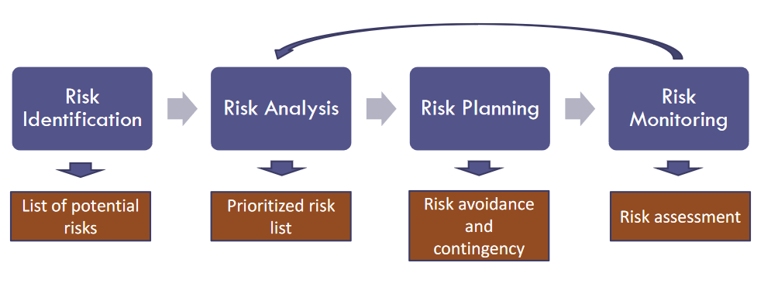

**STEP1-Risk Identification**

Risk Identification is the process of identifying all possible outcomes that pose a risk or benefit to the project. These can be obtained by three events; milestones ,financial trajectory and scope**.** All members are to identify the risk and opportunity and be managed by the risk owner. It can also be characterized by who is responsible for its action(Risk Management Team Roles).

**STEP2-Risk Analysis**

This is divided into qualitative and quantitative risks.Qualitative assessment deals with analyzing the level of criticality based on the event’s probability and impact while quantitative assessment focuses on the financial impact or benefit of the event.

**STEP3-Risk Treatment**

An organization needs to identify and develop strategies into a treatment plan.This is to reduce the probability as well as mitigate the impact of the risk. The aim is to increase the chance of occurrences and reduce the risk involved.

**STEP4-Risk Monitoring**

Every step of risks and opportunities and their respective treatment plans must be monitored and detailed. By doing monitoring, it makes certain that there are proper avenues for escalation and appropriate risk responses are executed.

# Deliverables (Aleks)

| No | Artifact Name | Responsible Party |
| --- | --- | --- |
| 1 | Project proposal | All |
| 2 | PID document | PM (Project manager) |
| 3 | Project Plan, RACI | PM |
| 4 | Requirements types | PO (product owner) |
| 5 | Analysis diagrams | Lead BA (Business analyst) |
| 6 | User requirements | PO |
| 7 | RCT | Lead BA |
| 8 | Functional requirements | PO / Lead BA / PM |
| 9 | DB model, ER diagrams (2) | Lead DBA (Database administrator) |
| 10 | Architecture diagrams (2) | Lead Dev/DBA |
| 11 | UML design diagrams | Lead BA |
| 12 | Test documentation | Lead QA |
| 13 | Code sample and demo | Lead Dev |
| 14 | Project Presentation | All |

# Stakeholders (Yash)

| Stakeholder | Interest |
| --- | --- |
| Local restaurants and Food Retailers | Provide the food that would otherwise be disposed of by listing the item they wish to make available |
| Volunteers/NGOs | Responsible for claiming the food provided by the restaurants and food retailers and redistributing it to the needy |
| Food Receivers | The people to whom the food will be delivered by the volunteers and NGOs and be consumed by them |
| CC companies/ Financial Technology Company | Provide payment gateways and in-app subscriptions |
| Sales Assistants | The assistants are in charge of finding new stores to increase the number of partners |
| Support Team | Provide additional in-app support and resolve issues faced by the end users |

# Project Team (Aleks & Pratikkumar)

The project team includes the following roles:

* Project Manager – Yash Kawade
* Product Owner – All members of Team 5 on a biweekly rotation principle
* Lead Developer – Aleks Kamenev
* Developer - Christus Martey
* BA Lead - Yashraj Bhandare
* Business Analyst – Yash Kawade
* QA Lead – Pratikkumar Chaudhari
* Tester – Venkata Satya Preethi Nimmakayala
* DBA – Christus Martey

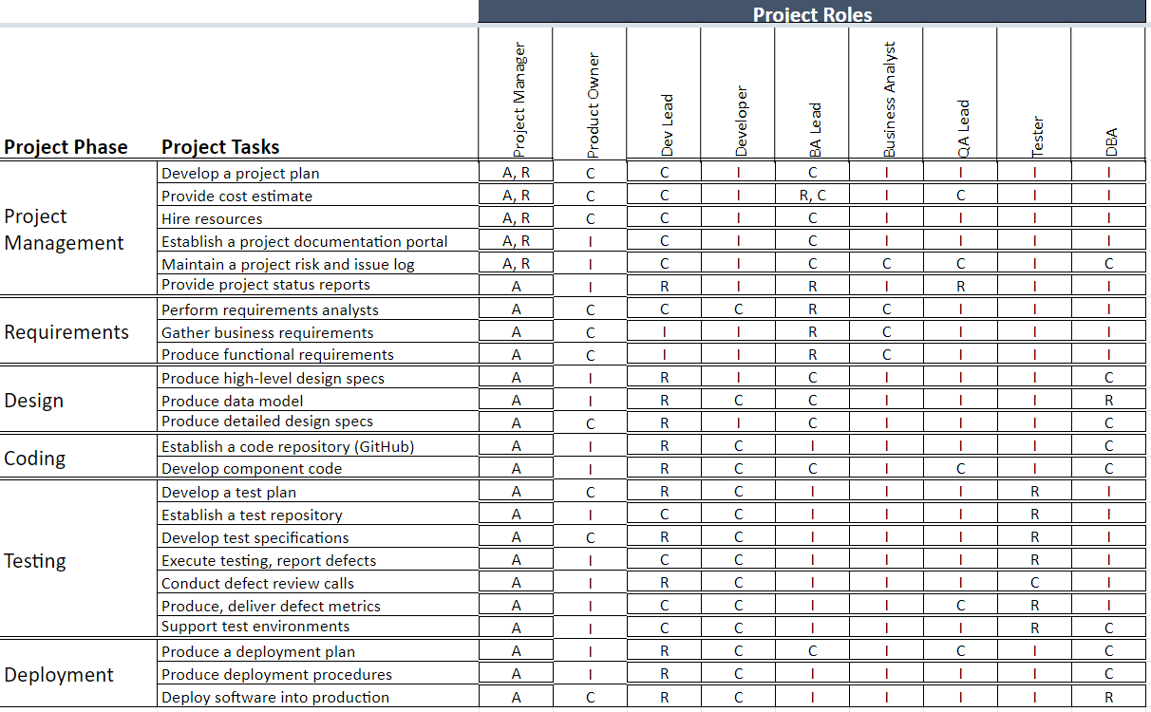

# Project Plan (Yashraj)

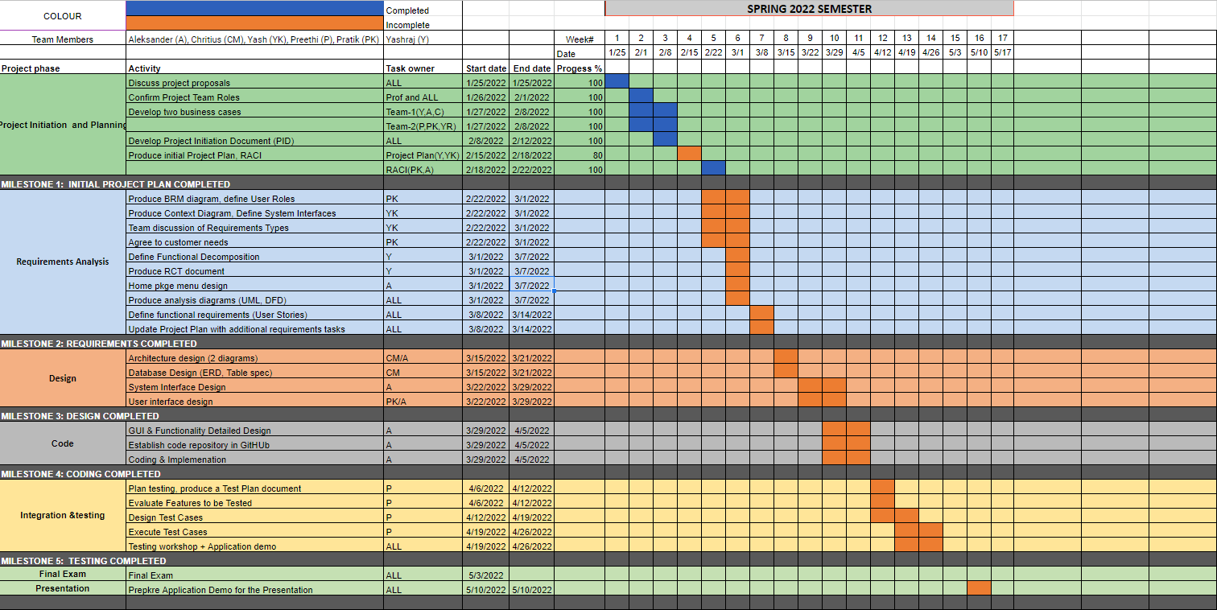

# Project Controls (Venkata)

The project manager and team should stay closely involved to meet the needs of the project and work in an operational environment. Project Team meetings will be conducted twice per week.

The minutes of meetings will be mailed by the Project manager to the Professor for approval, and team members after each meeting.

To communicate, the team members will connect through Slack, Gmail, and Zoom meetings being held twice a week to discuss and make decisions regarding the tasks related to the project work.

An atmosphere of allowing input from all team members and being respectful of opposing views will be maintained, keeping the mission of the project paramount.

Changes to any part of the project need to be reviewed, approved, and documented in the same way that the original part of the plan was approved.

As a team member and participant in the meeting, it is important that all review the progress to accurately report actions taken on the agenda.

# Communication Plan (Pratikkumar & Venkata)

| Stakeholder | Frequency | Type | Purpose |
| --- | --- | --- | --- |
| Professor | At key stages - meetings and deliverable drafts | Outlook/Slack | To guide regarding the project implementation and suggestions about the future scope |
| Project Manager | Twice a week | Outlook/Slack | To discuss working progress and keep track of deliverables.  To discuss any  issues related to  communication between team members. |
| Food Givers/Donors  (Food retailers and restaurants) | At key stages | Online marketing | To bring in a strong initial base of “giver” class users and to periodically check in with organizations throughout the life of the platform. |
| Project Team | Daily | Zoom, Slack, Gmail | Maintain progress and ensure that the team is meeting weekly requirements |
| Couriers and Receivers  (NGOs, volunteers, and food receivers) | Possibly during the testing period as well as after the release. | Email, online testing sessions | Feedback about the UI and accessibility of the app |